Virtual worlds

Final Project Documentation

Dominic Russo

1989 Soviet Exploration Game

# Link to video

Good ending: <https://youtu.be/VA9p7wUAROs>

Bad ending: <https://youtu.be/hAwZg11oDZw>

# Summary:

You play a character named Vitaly who lives in an apartment located in a satellite state belonging to the Soviet Union. As you watch the Berlin Wall fall on live TV, your buddy Anton drops a note under the door; he’s found a recently abandoned train station to explore that’s nearby an old nuclear station. Now seems to be the perfect time to investigate…

# Theme or concept:

An everyday person stumbles into a potentially cataclysmic situation, do they have what it takes to save the world?

# Blueprints

Apartment:

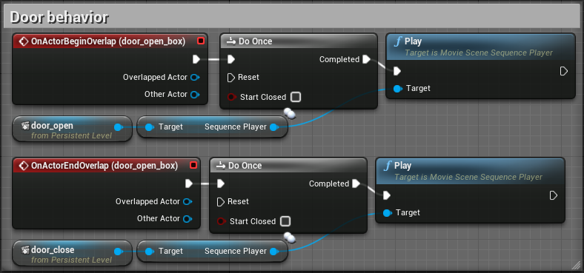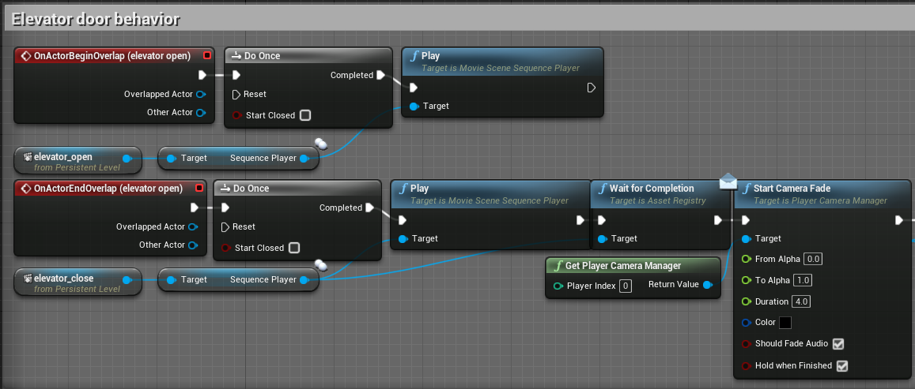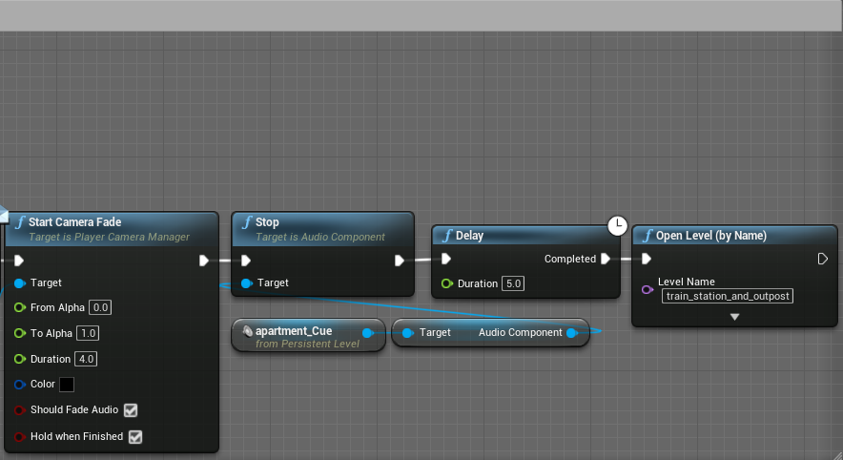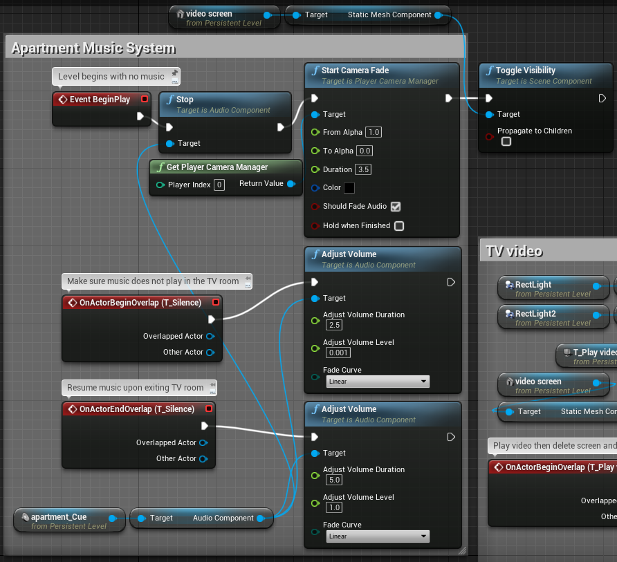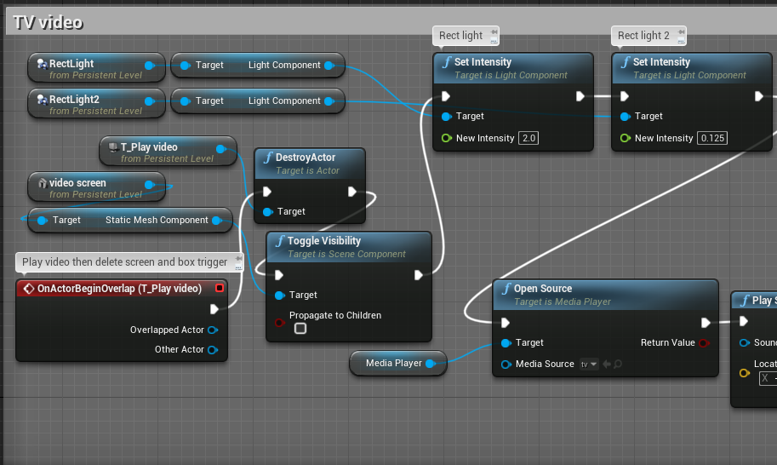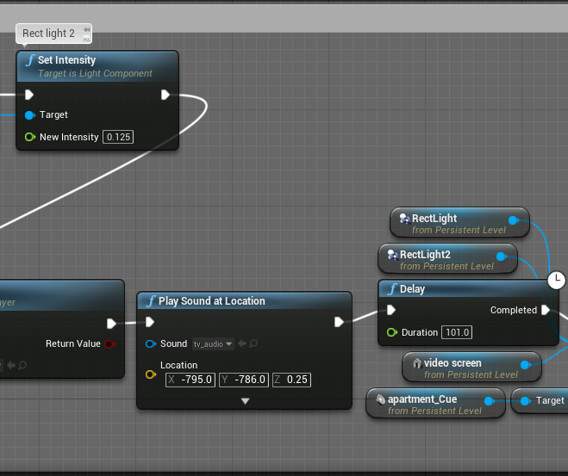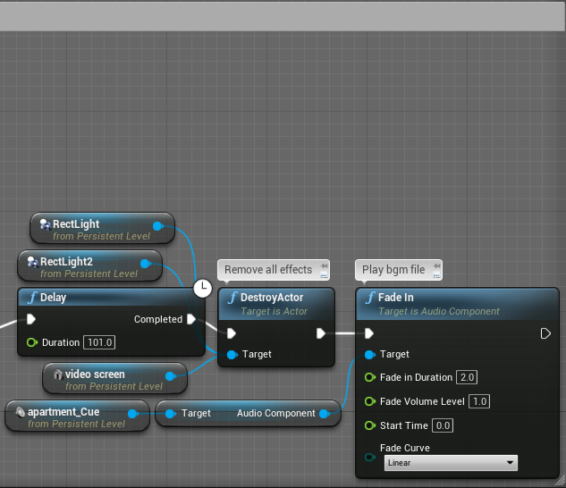

Train station/military bunker:

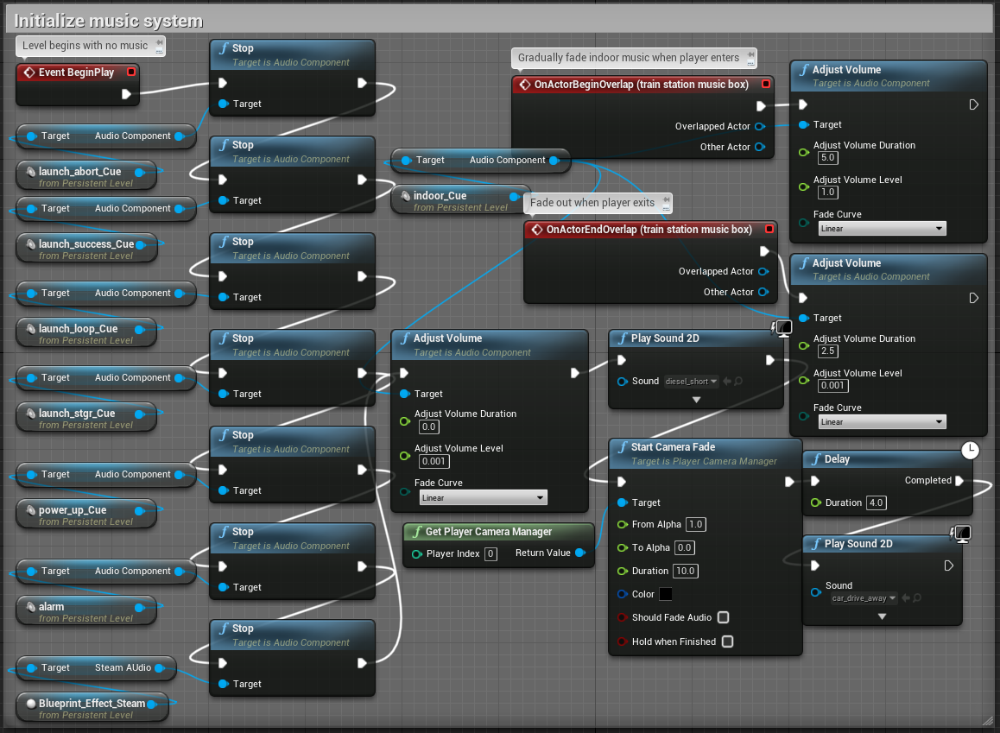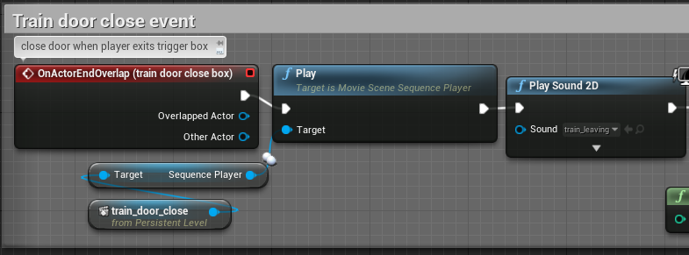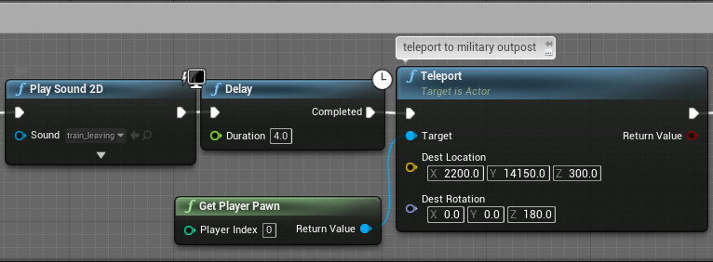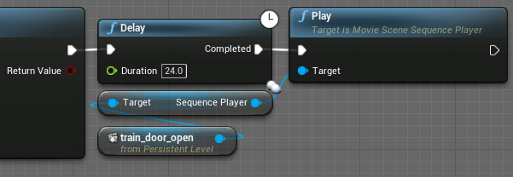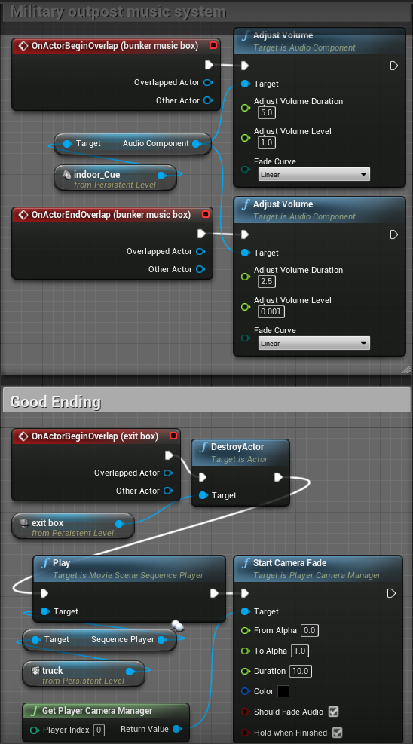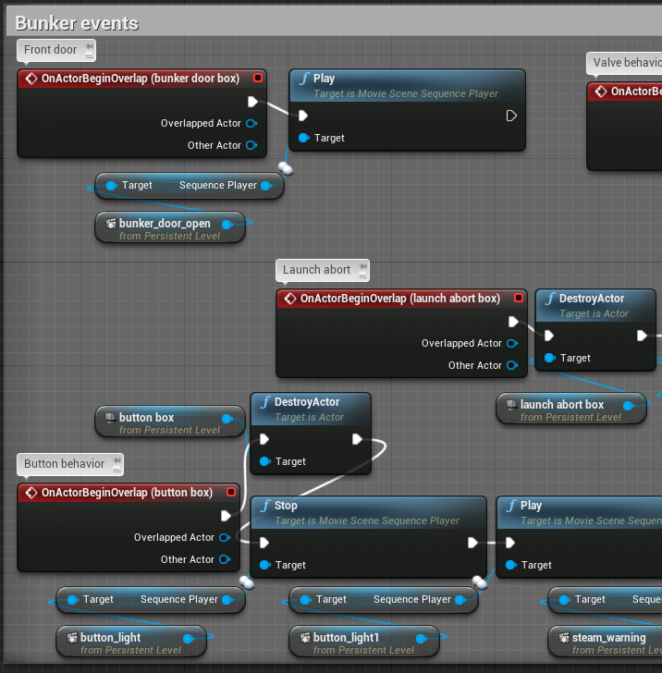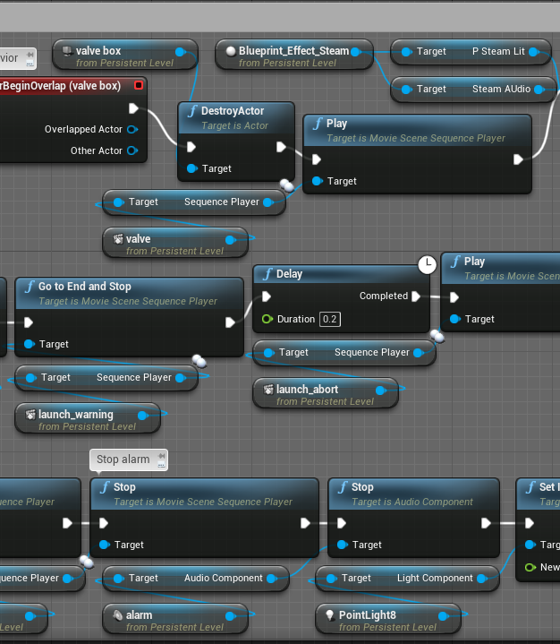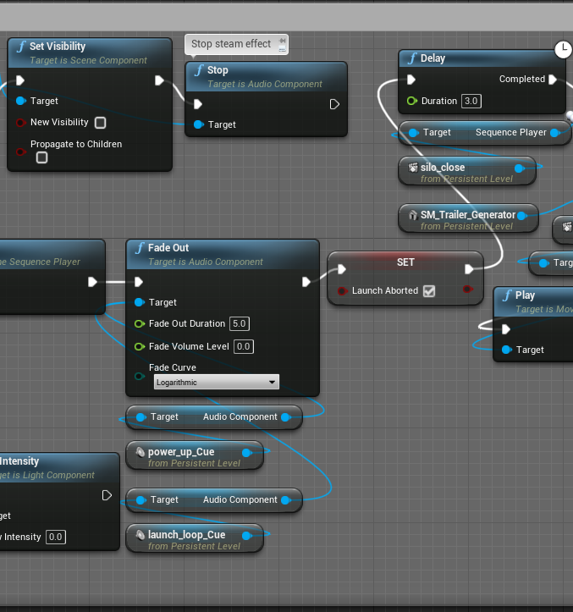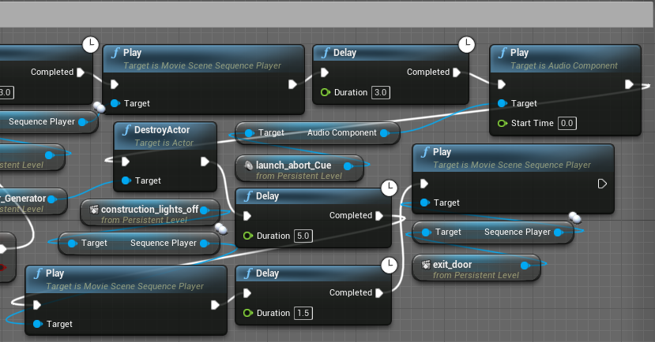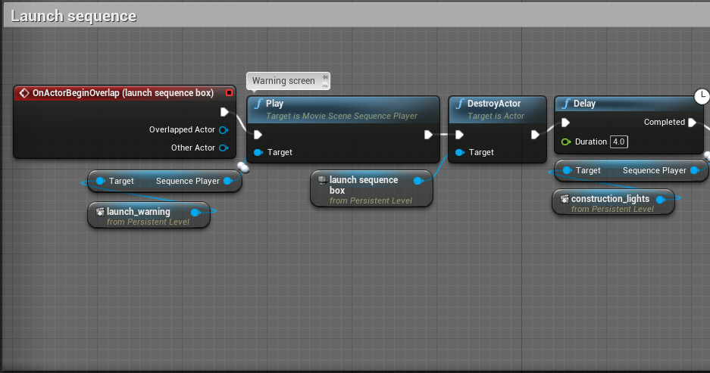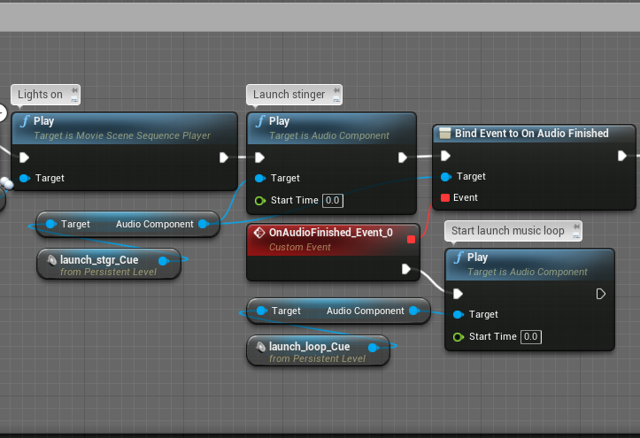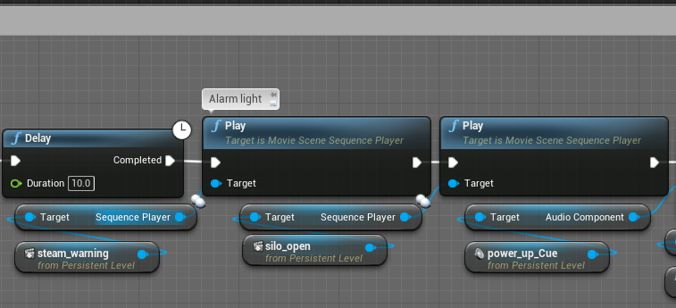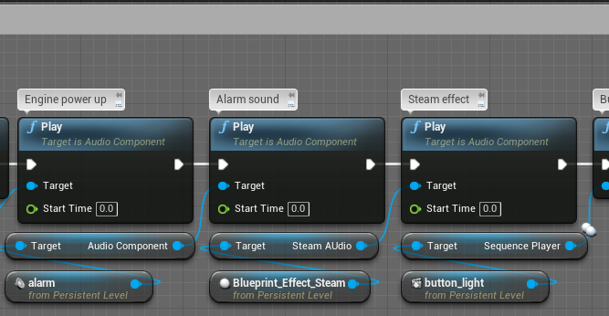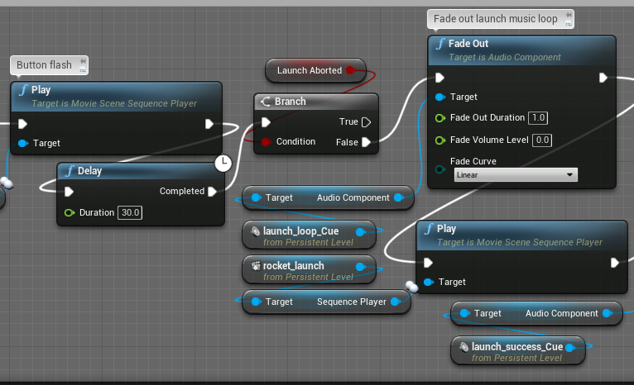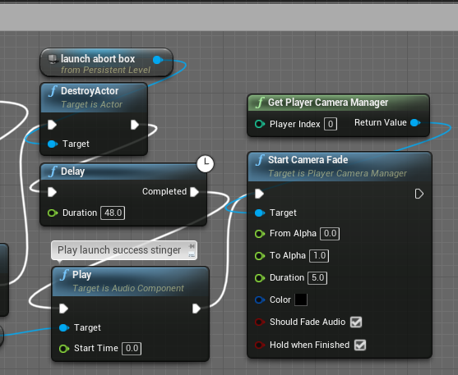

# Visual References (link and images)

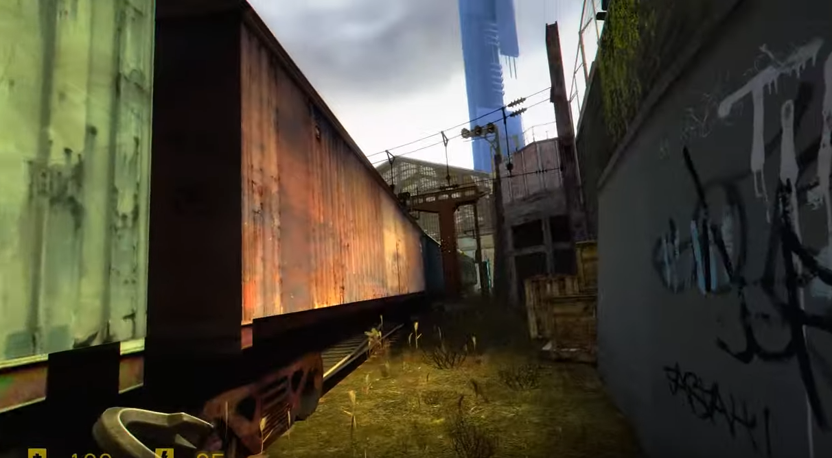

Half Life 2 MMod - <https://www.youtube.com/watch?v=U6xcxnzeVB0>

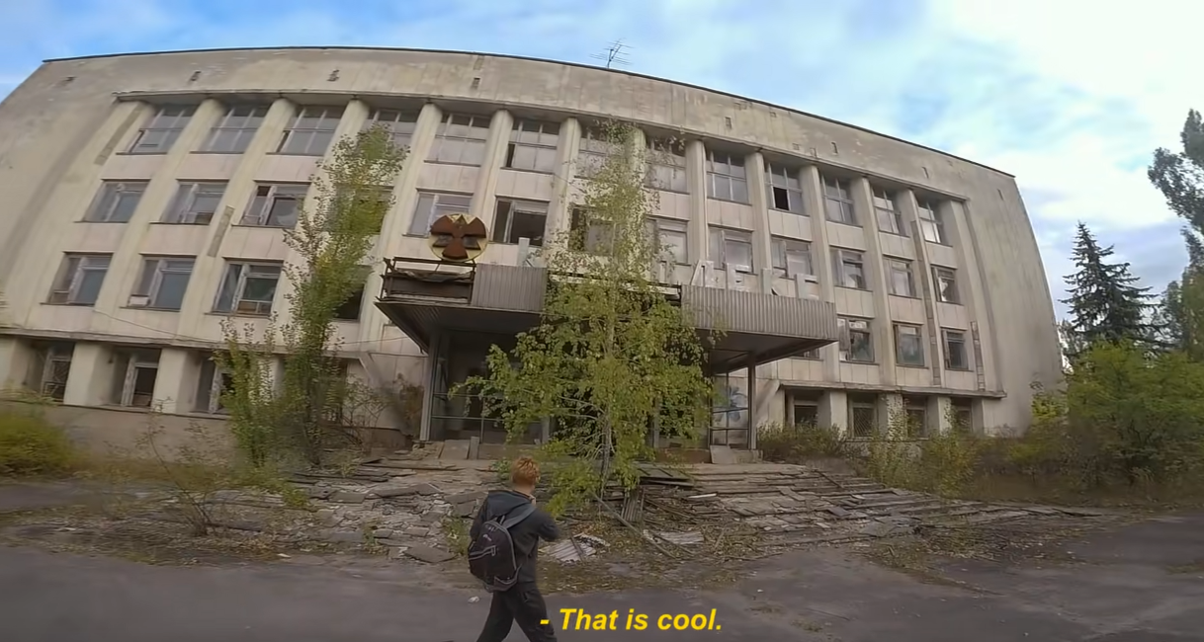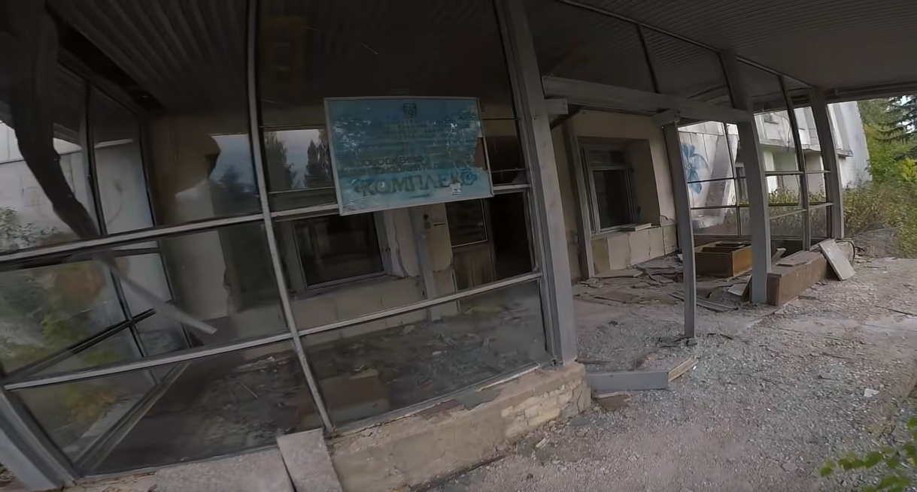

shiey, journey across Chernobyl exclusion zone - <https://www.youtube.com/watch?v=jGPjj4B_jEk>

# Assets utilized:

## Audio/Video

Berlin wall news report: <https://www.youtube.com/watch?v=snsdDb7KDkg>

TV static: <https://www.youtube.com/watch?v=NYWTlVD4vDs>

Elevator ding: <https://www.youtube.com/watch?v=axOEsMYwTcY>

Door open sound: <https://www.youtube.com/watch?v=OohvbnXhtXA>

Door close sound: <https://www.youtube.com/watch?v=ykQri9nqQGQ>

Train leaving sound: <https://www.youtube.com/watch?v=T1otCPZAJ7c>

Valve turning sounds: <https://www.youtube.com/watch?v=-h4rwKtG-FM> <https://www.youtube.com/watch?v=7sAF8iazq9c>

Button press sounds: <https://www.youtube.com/watch?v=Xp3TsuVgbJQ>

Computer beeps: <https://www.youtube.com/watch?v=lu5rMfgesgs>

Jet engine power up: <https://www.youtube.com/watch?v=gQGQmYqolws>

Power down: <https://www.youtube.com/watch?v=RP_HQe-LyIM>

Rocket launch sound: <https://www.youtube.com/watch?v=OMY0Z4Rf8D8>

Power switch on sound: <https://www.youtube.com/watch?v=mKVnBV58ddE>

Truck starting: <https://www.youtube.com/watch?v=oQZqnPLUiBE>

## Sketchfab Models

Old couch: <https://sketchfab.com/3d-models/old-couch-443d9bb95e944afe8ebc4ff489e2886c>

90’s TV (I removed the number 17): <https://sketchfab.com/3d-models/90s-tv-369f46d2bf534bb3ad4f1bc4d05e437d>

Wall light: <https://sketchfab.com/3d-models/wall-light-c723fa0a1ac3478790192acdb39161b0>

Desk lamp: <https://sketchfab.com/3d-models/table-lamp-4b5bbcccea5d4ef59ca16efe65d8948d>

Table lamp: <https://sketchfab.com/3d-models/old-table-lamp-dd1b521edd1142bfa23b900665460013>

Floor lamp: <https://sketchfab.com/3d-models/pbr-floor-lamp-free-download-083c9408b89949d8b201e8a1bb6ce41c#download>

Bedside table: <https://sketchfab.com/3d-models/bedside-table-2cdb30045bf84c3a82c4defe2bbcc516#download>

Old kitchen props: <https://sketchfab.com/3d-models/old-kitchen-the-grandmas-kitchen-9cf1f9177c554799bc09bbc8a77efe76>

Fridge: <https://sketchfab.com/3d-models/ussr-old-refrigerator-7d12f05773a6403c9ca259ed43604c69>

Gas stove: <https://sketchfab.com/3d-models/gas-stove-056ccf898f9e49acb6e3e370deabf184>

Kitchen counter: <https://sketchfab.com/3d-models/old-kitchen-cabinets-48b931482fe9489ab222ffbda838b753>

Kitchen cabinets: <https://sketchfab.com/3d-models/hanging-kitchen-cupboards-9885af710e4047539ac7bc8f08f3de51>

Chairs: <https://sketchfab.com/3d-models/chair-c226b9e0cace4a20bf017b7061ada18d>

Kitchen table: <https://sketchfab.com/3d-models/tavern-table-d970ab7173c243acb7f3187f502a1ca0#download>

Elevator: <https://sketchfab.com/3d-models/small-elevator-7c81a5fe2f6e41dea08403061bdb06d2#download>

Bunker light: <https://sketchfab.com/3d-models/bunker-light-clean-and-damaged-86d1e33aad0b4b3ab2f2cf3d1fc6325d>

ICBM: <https://sketchfab.com/3d-models/icbm-ss29-87d991a7ca754f309184c000dce2afcd>

Missile silo: <https://sketchfab.com/3d-models/missile-silo-low-poly-8f19a60d4d8a44efa42eea3d781dda19>

Russian button: <https://sketchfab.com/3d-models/button-start-stop-ussr-cb6904be8caf437a86906a2252ac0307>

Bed: <https://sketchfab.com/3d-models/bed-ea1152935b9049e4a0fcc949ebd31fa1#download>

## Textures

Carpet: <https://3djungle.net/textures/carpet/6638/>

Floor: <https://3djungle.net/textures/old/794/>

Wallpaper: <https://wallpaperaccess.com/classic-vintage>

## Google Translate

Опасность! Запуск ракеты – Danger! Missile launch

Запуск прерван – Launch aborted